**Mashrafe Bin Mortaza**

[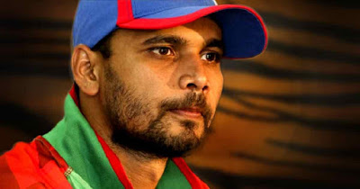](https://4.bp.blogspot.com/-v1m6eAvMeH8/W7c0MZcxCcI/AAAAAAAAAIo/ReRsVwk6pzkS9WBe0PQ5h7VSnAQ8wl-kACLcBGAs/s1600/Mashrafe-bin-Mortaza.jpg)

There is a cricketer who is not only a cricketer but also considered as a whole nation himself. He is the first cricketer who is still playing after seven surgeries. Usually, cricketers don't play after two knee injuries but this man is not like the others. Yes, I am talking about [Mashrafe Bin Mortaza](https://en.wikipedia.org/wiki/Mashrafe_Mortaza). Present captain of [Bangladesh cricket team](https://en.wikipedia.org/wiki/Bangladesh_national_cricket_team).

Ever seen anyone who sacrifices himself for the country? This man has. His whole career was full of injuries one after the another. Everyone thought that he will not come back to cricket. But Mortaza never gave up. He fought face to face with all the injuries and came back bravely as a great captain Bangladesh cricket ever had.

[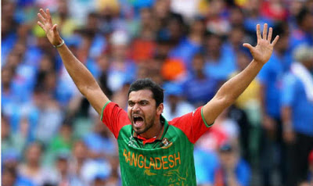](https://3.bp.blogspot.com/-pIKj05ZPDaM/W7c0cMYT0tI/AAAAAAAAAIw/yxz6vUNBmeMr0GAucc-PxhexxY6jgQflgCLcBGAs/s1600/mortaza.jpg)

**Unknown facts**

**Nicknames:**

His nickname is Koushik. But there are lots more. For his good bowling, he is known as 'Narail Express'. Some call him 'Mash'. When he was in college, his nickname was 'King Of The Heart'.

**Family:**

In college, Mortaza had a girlfriend named Shimu. But now she is Mortaza's wife. They have two children. One girl named Humayra Mortaza and a boy named Sahil Mortaza.

[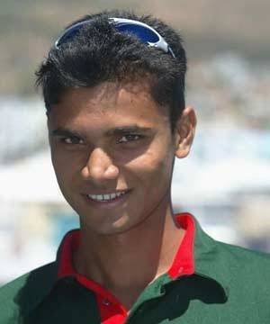](https://4.bp.blogspot.com/-2pKXKN6fKT4/W7c0rJY_pKI/AAAAAAAAAI0/tdEll1mCiT4h3SganUeIcqmhrzPTZpIxQCLcBGAs/s1600/e7771307f2bc38ffb192333fc2350752_m.jpg)

**Starting of the career:**

Mortaza got the chance of playing in the national team by playing just one match in the A team of Bangladesh cricket. His debut ODI match was against Zimbabwe On November 23, 2001, at Dhaka.  His first maiden test wicket was [Grant flower](https://en.wikipedia.org/wiki/Grant_Flower) which considered as a big prize for a debut test match. After the test series against Zimbabwe and one against Pakistan in January 2002 he was unable to play about eight months for an injury.

**Injury Plagued Career:**

After these two test series, Mortaza was suffering from back injury. While recovering he suffered from a knee injury. As I said that moment he was unable to play eight months. He played just twelve test match in first three years of his career. He has had operations on his ankles, legs and knees. Total he had seven surgeries.

[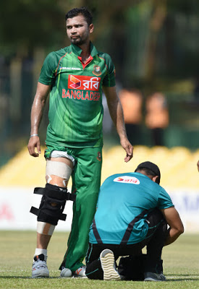](https://1.bp.blogspot.com/-CNYT4ZjQkFw/W7c0xC2cqdI/AAAAAAAAAI8/zoWuEGlwDWc0v6Oyt5jcz0XtqXqz8f7lACLcBGAs/s1600/260821.jpg)

**Come Back:**

For frequently injuries he never continued test matches. But he plays limited overs matches. Yet we see him suffering in the field like pulling knee plat upon the knee.

**Achievements:**

In 2004 playing against India Mortaza delivered his dream spell and 31 runs not out. Also got the man of the match award for this. Bangladesh won that match over neighbours India. His best bowling figure is 6/26 vs Kenya. 2015 world cup was his best achievement as captain. On that world cup, Bangladesh qualified for the quarter-final.